**CST8912 – Cloud Solution Architecture**

**Graded Lab Activity #4**

1. Compose the appropriate networking, compute, storage, and database services to meet the operational requirements of various application scenarios.

* Design cloud architecture layers and their function to maximize reliability and resiliency of application services
* Outline core architectural components to meet the operational requirements of various application scenarios
* Describe cloud service models (IaaS, PaaS, SaaS) and implement highly available and elastically scalable solutions
* Identify the core features of cloud computing and their interactions with each service layer

**Introduction:**

A cloud database is a database service built and accessed through a cloud platform. It serves many of the same functions as a traditional database with the added flexibility of cloud computing. Users install software on a cloud infrastructure to implement the database.

Key features:

* A database service built and accessed through a cloud platform
* Enables enterprise users to host databases without buying dedicated hardware
* Can be managed by the user or offered as a service and managed by a provider
* Can support relational databases (including MySQL and PostgreSQL) and NoSQL databases (including MongoDB and Apache CouchDB)
* Accessed through a web interface or vendor-provided API

**Purpose of this hands-on Lab that can be simulated in any CSP**:

In this lab, you will explore the main features of cloud SQL database for azure and learn how to deploy and manage the service by connecting and querying the database, copy data from source to target using azure data factory. In this lab, source is azure sql database (a PAAS service provided by Microsoft) and destination is azure storage account container.

1. Configure Azure SQL database for Canada central region under your resource group cst8912-demo, choose single database under sql databases in sql deployment option /1

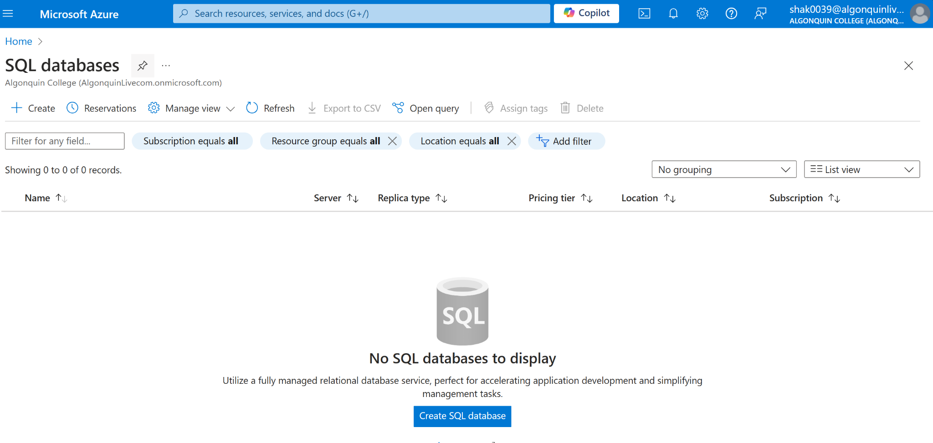

1. Enter the following values in create database page and keep other properties with their default settings /4   
   **Subscription:** Select your Azure subscription

**Resource group: CST8912-demo**

**Database name: db8912**

**Server:** Select Create new and create a new server with a unique name in any Canada central location. Use SQL authentication and specify your name as the server admin login and a suitably complex password (remember the password - you'll need it later!)

**Server : db8912demo**

**Username:db8912_yourname**

**Password: dfguyt@234!  
Want to use SQL elastic pool?: No**

**Workload environment: Development**

**Compute + storage: Leave unchanged**

**Backup storage redundancy: Locally-redundant backup storage**

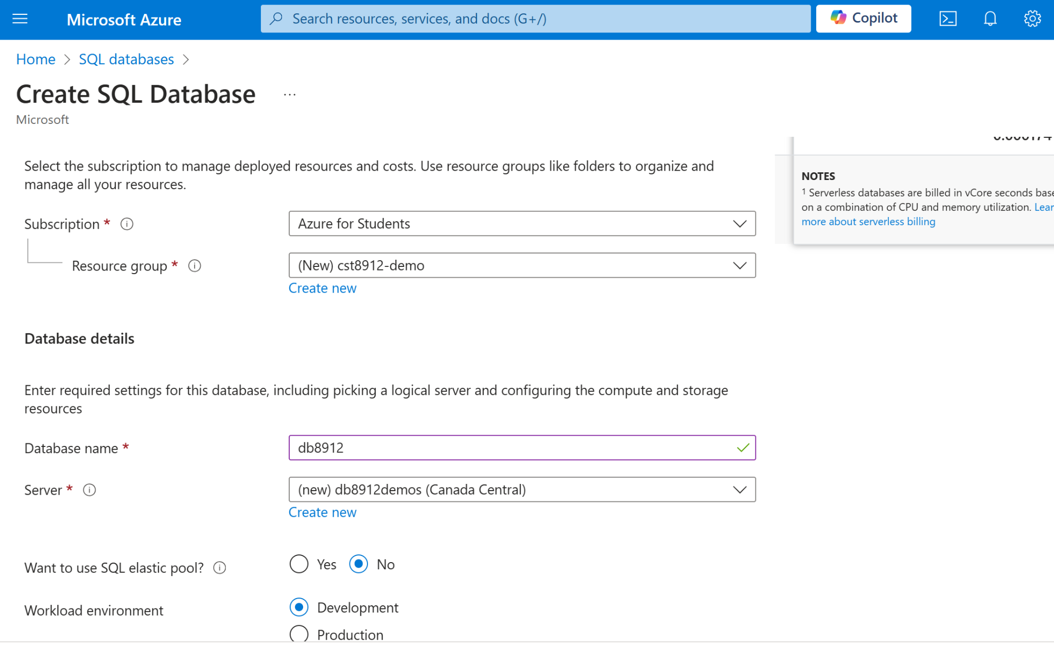

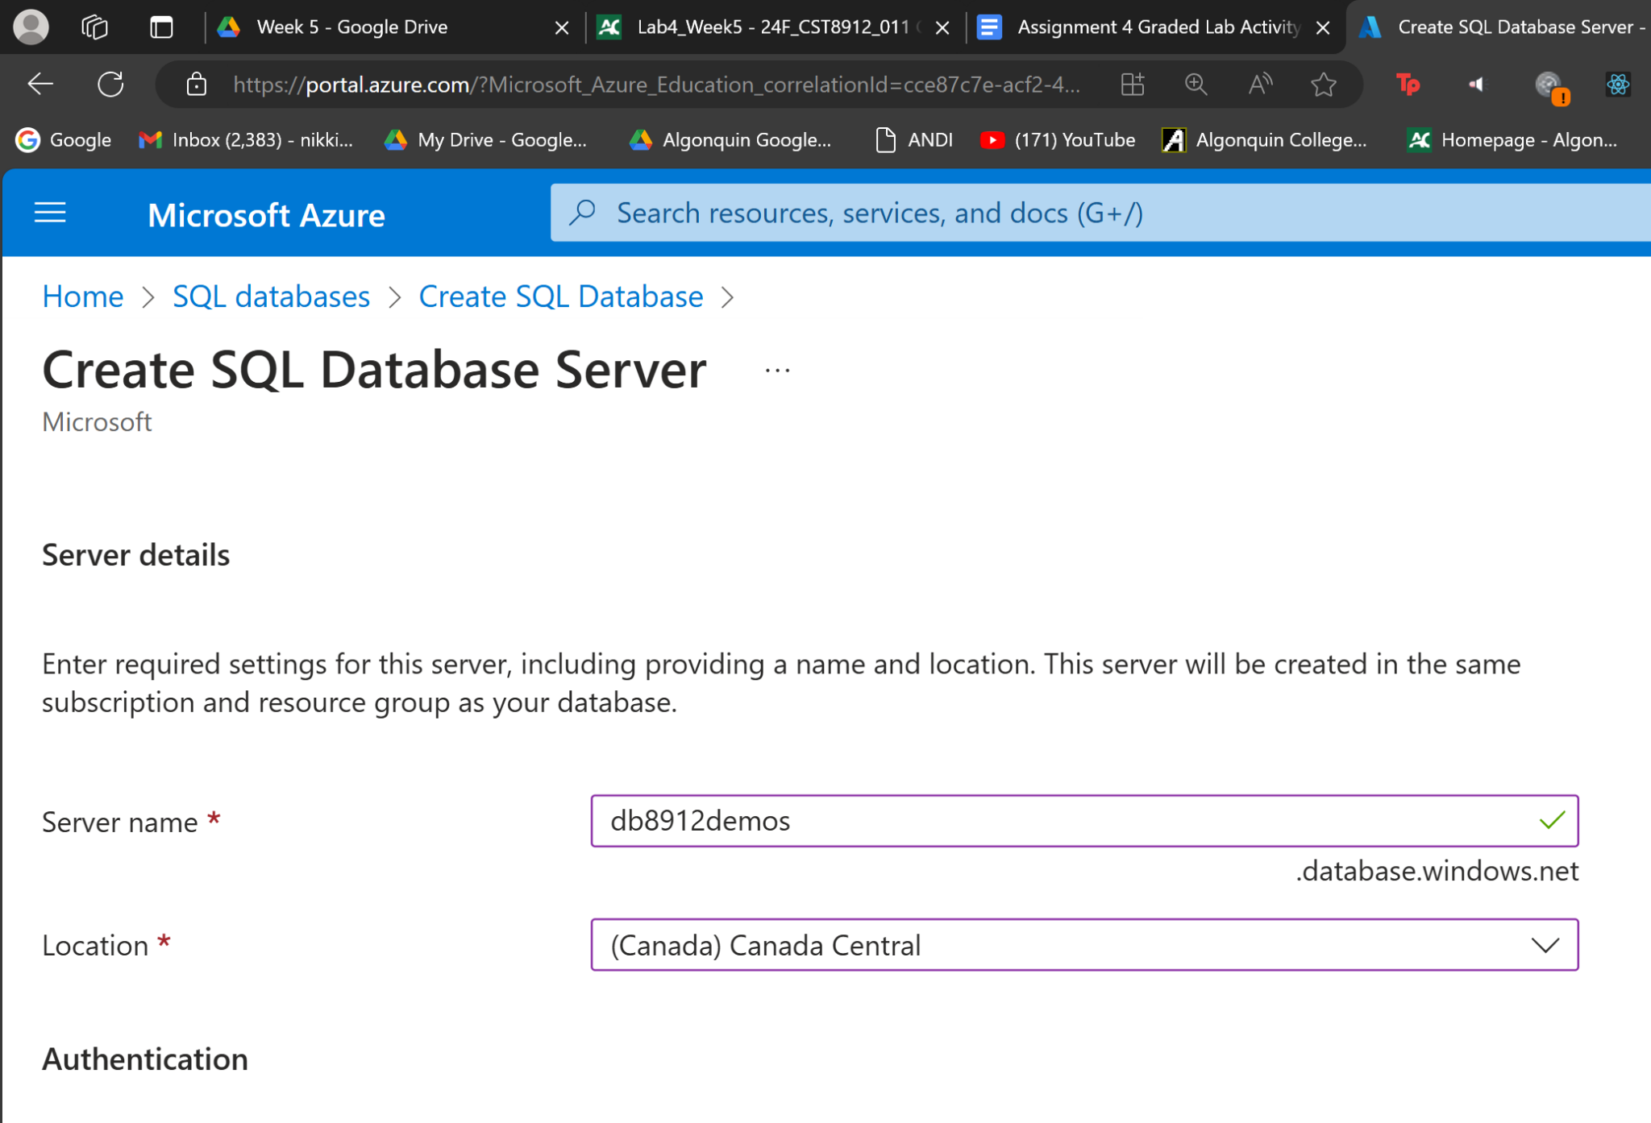

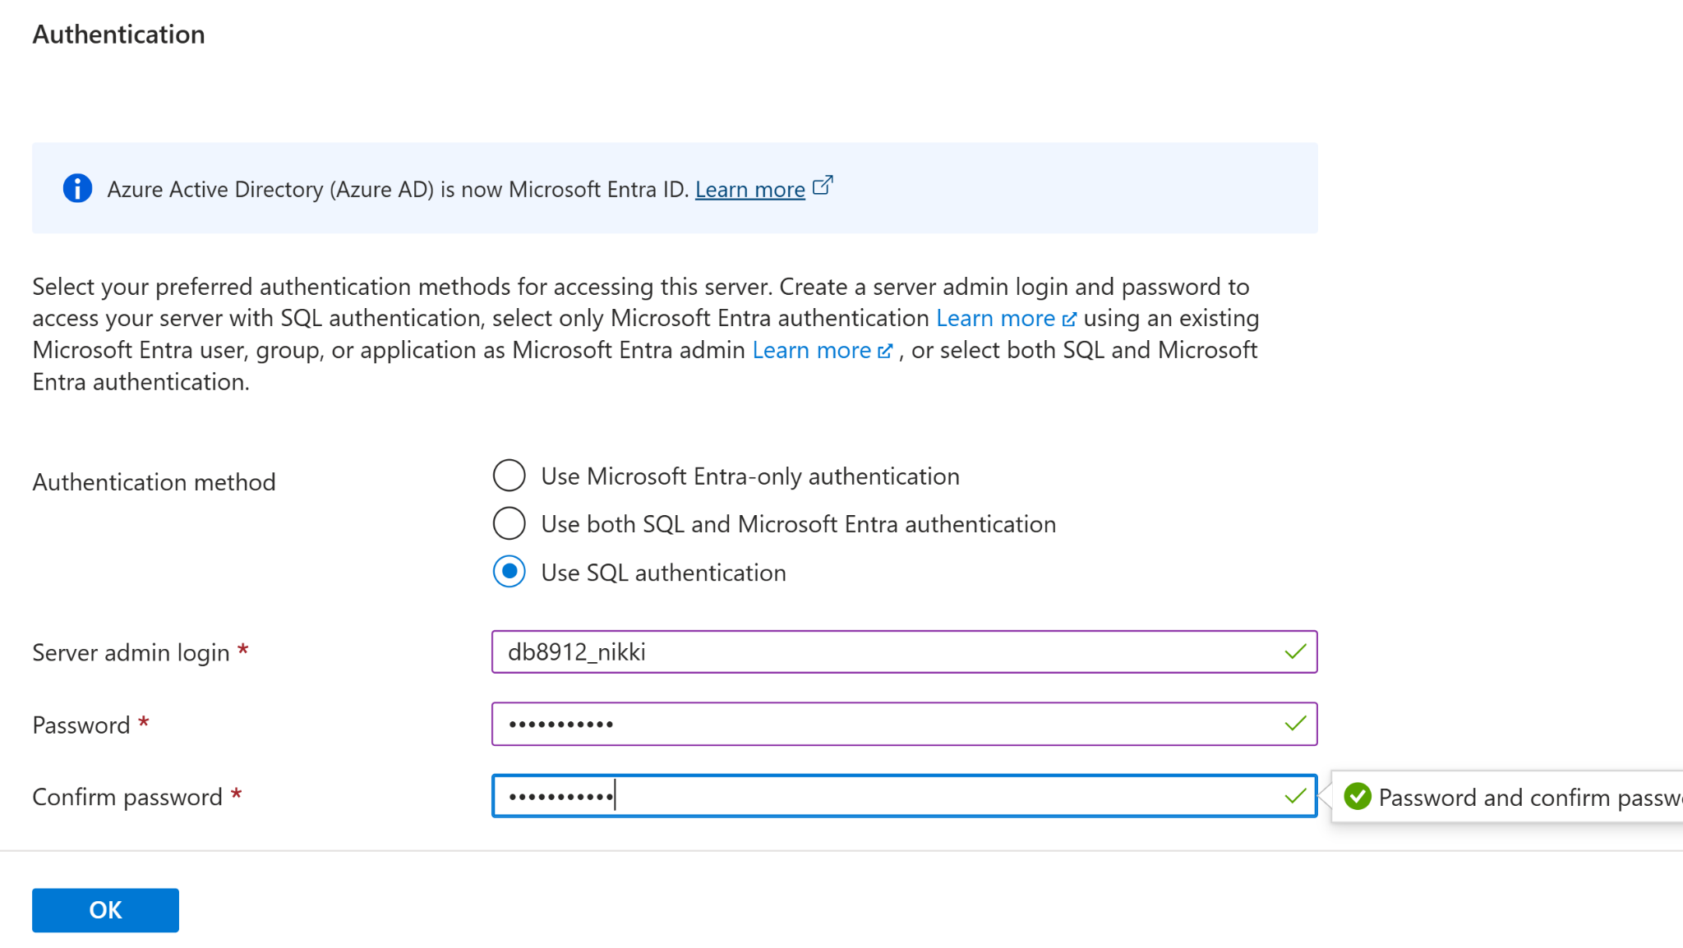

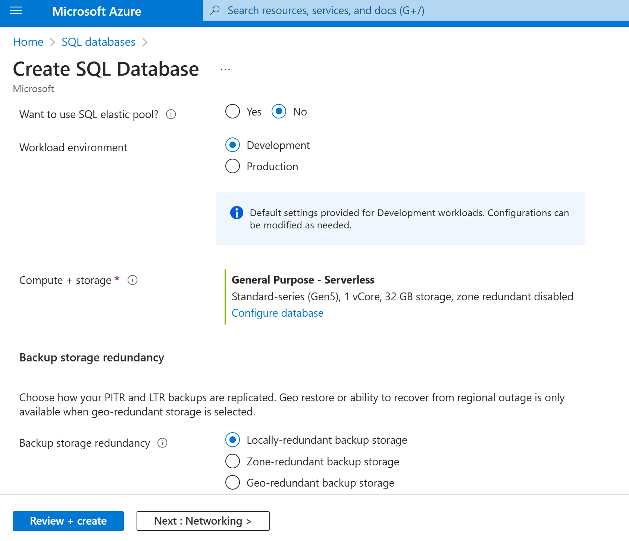

1. On the Create SQL Database page, select Next :Networking >, and on the Networking page, in the Network connectivity section, select Public endpoint. Then select Yes for both options in the Firewall rules section to allow access to your database server from Azure services and your current client IP address.

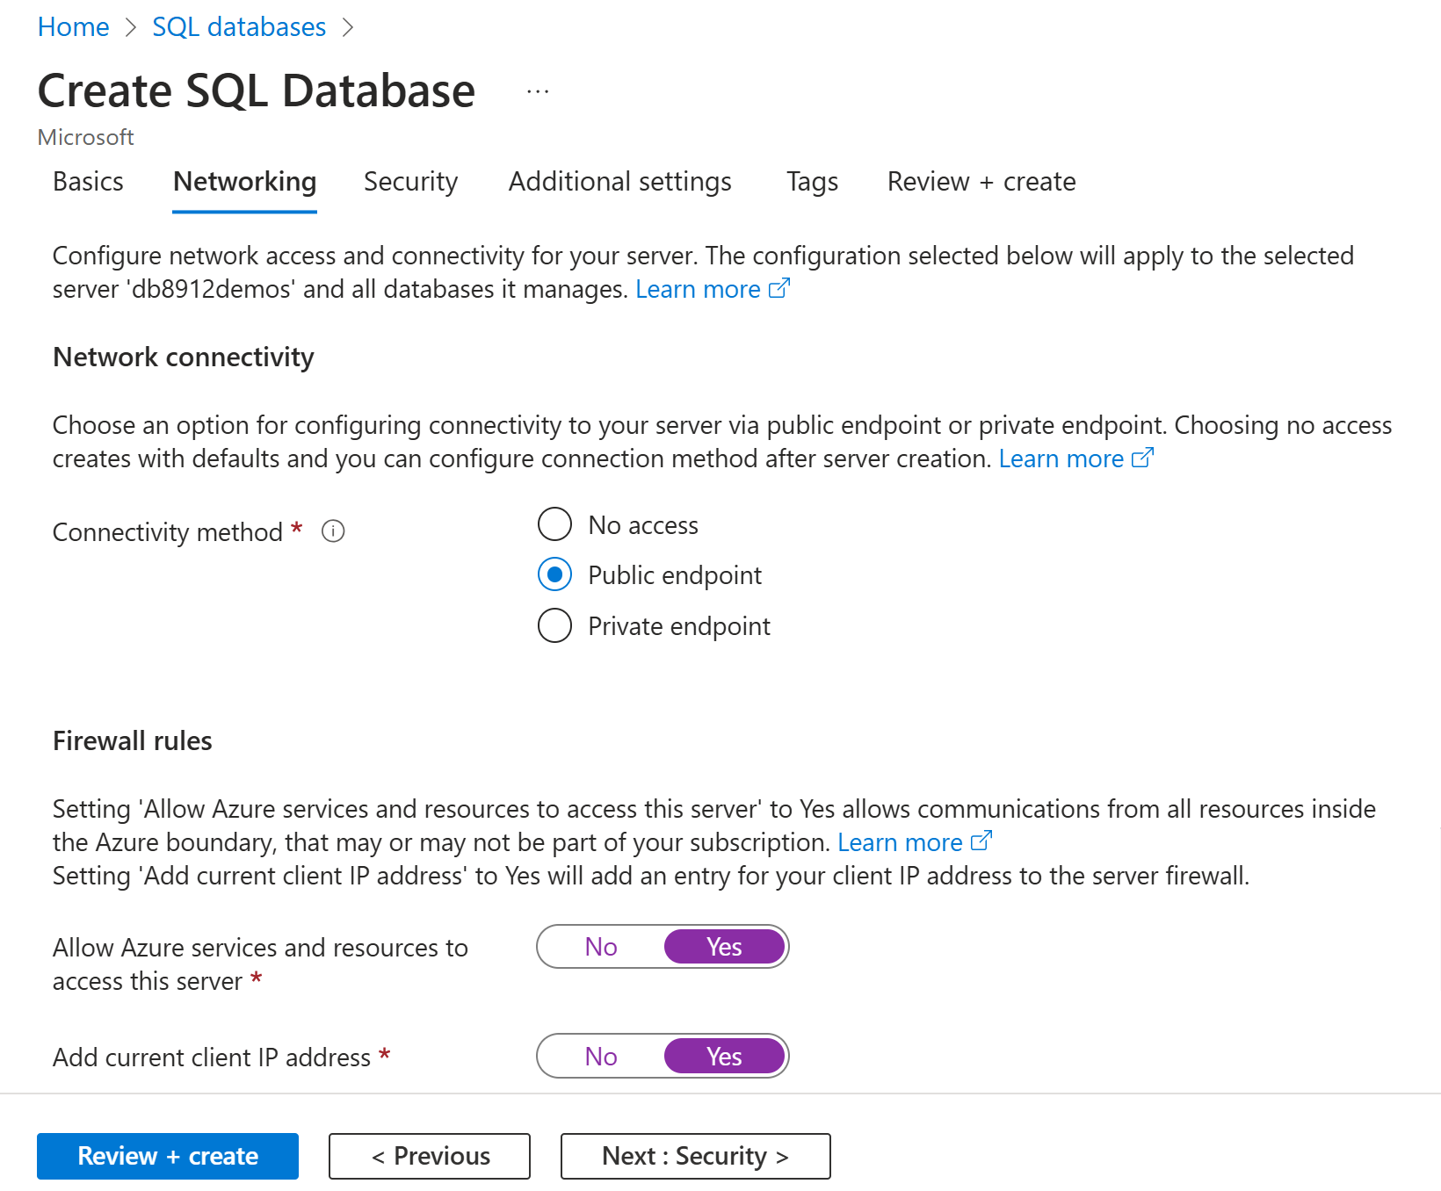

1. Select Next: Security > and set the Enable Microsoft Defender for SQL option to Not now.

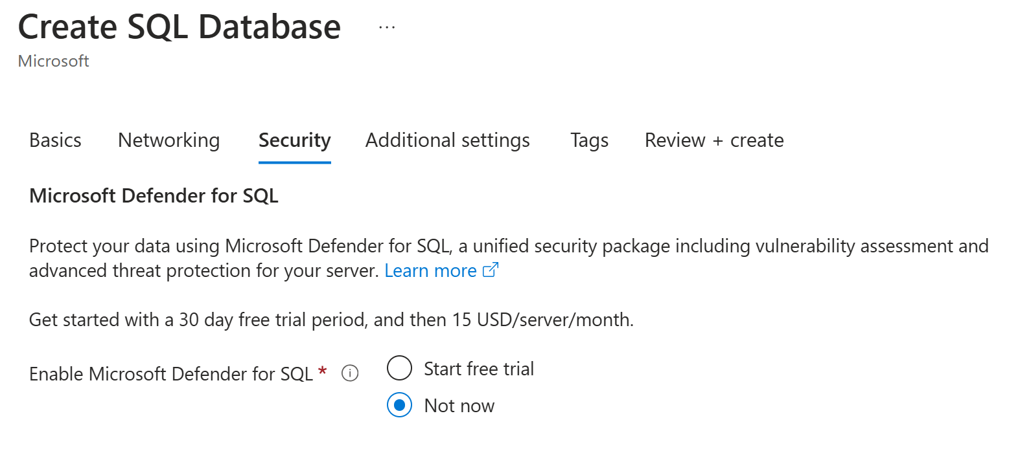

1. Select Next: Additional Settings > and on the Additional settings tab, set the Use existing data option to Sample (this will create a sample database that you can explore later).

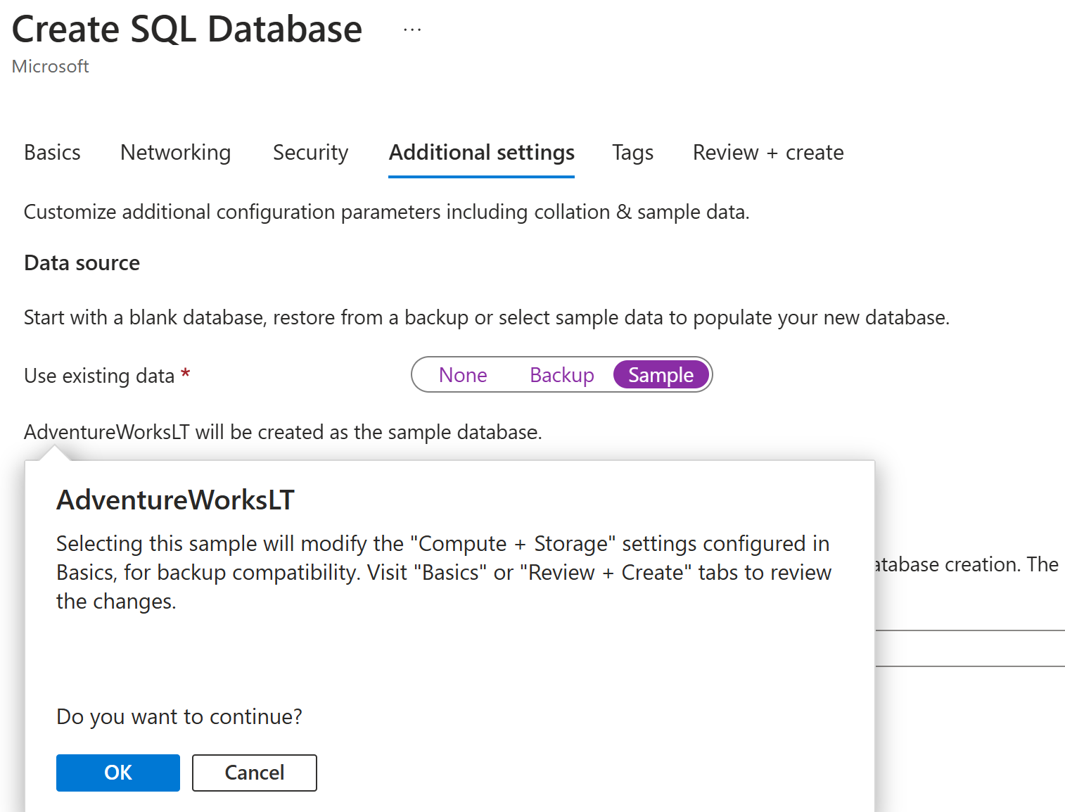

1. Select Review + Create, and then select Create to create your Azure SQL database.

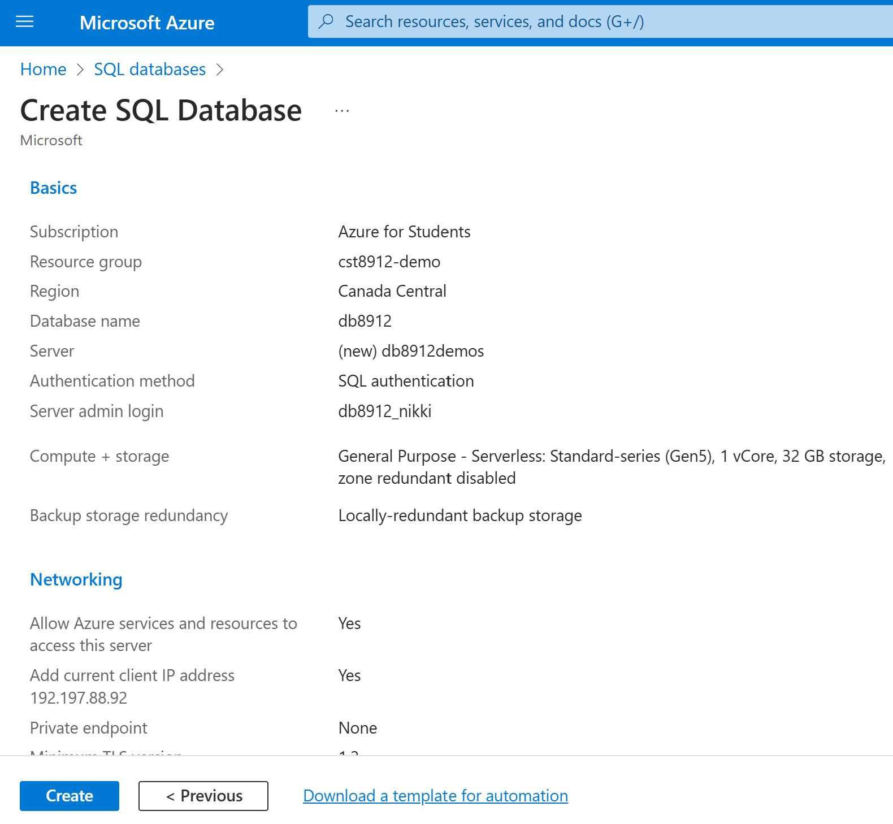

1. In the pane on the left side of the page, select Query editor (preview), and then sign in using the administrator login and password you specified for your server.

**Note** : If an error message stating that the client IP address isn't allowed is displayed, select the Allowlist IP ... link at the end of the message to allow access and try to sign in again (you previously added you own computer's client IP address to the firewall rules, but the query editor may connect from a different address depending on your network configuration.)

The query editor should look like this  
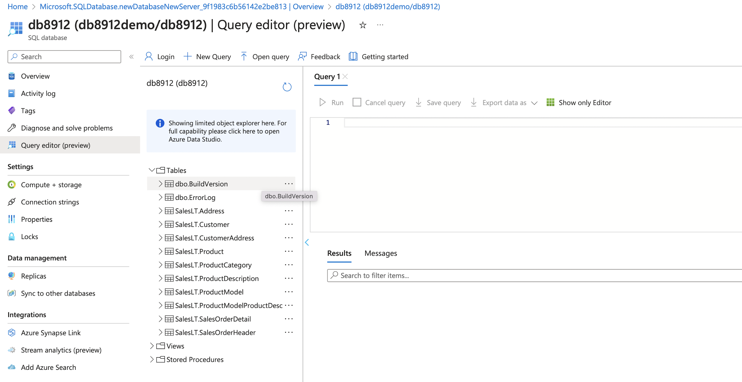

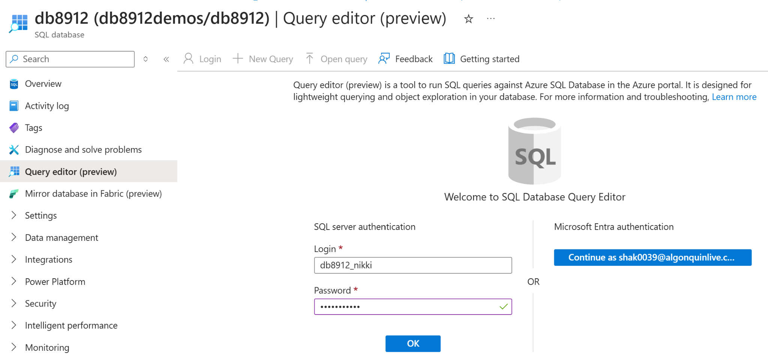

1. Expand the Tables folder to see the tables in the database

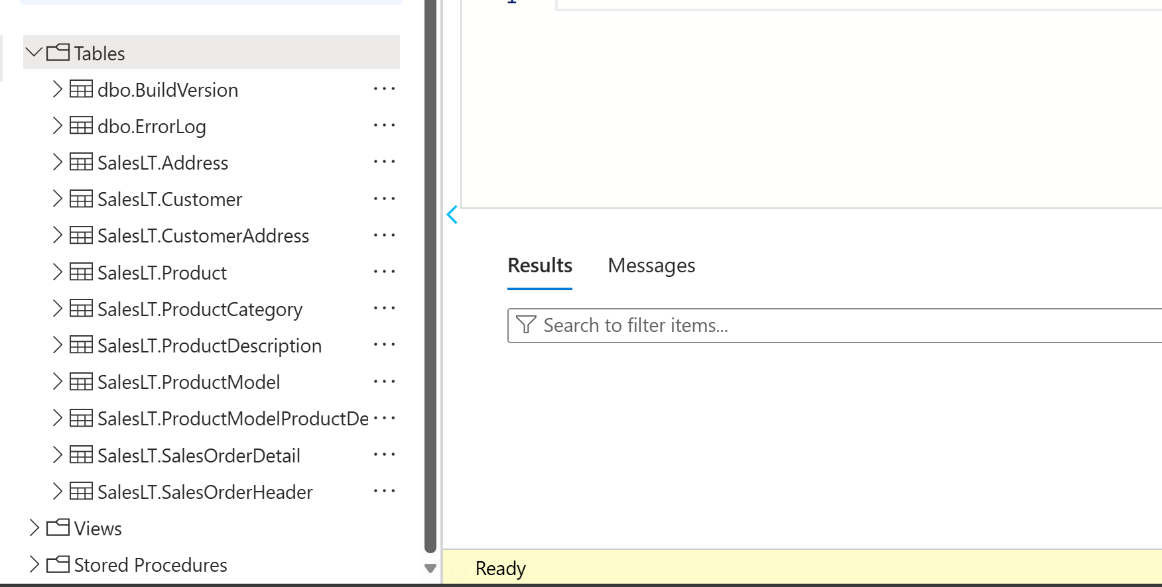

1. In the query 1 pane, try executing the following queries, select run to execute the query: /2

SELECT ProductID, Name, ListPrice, ProductCategoryID

FROM SalesLT.Product;

SELECT p.ProductID, p.Name AS ProductName,

c.Name AS Category, p.ListPrice

FROM SalesLT.Product AS p

JOIN [SalesLT].[ProductCategory] AS c

ON p.ProductCategoryID = c.ProductCategoryID;

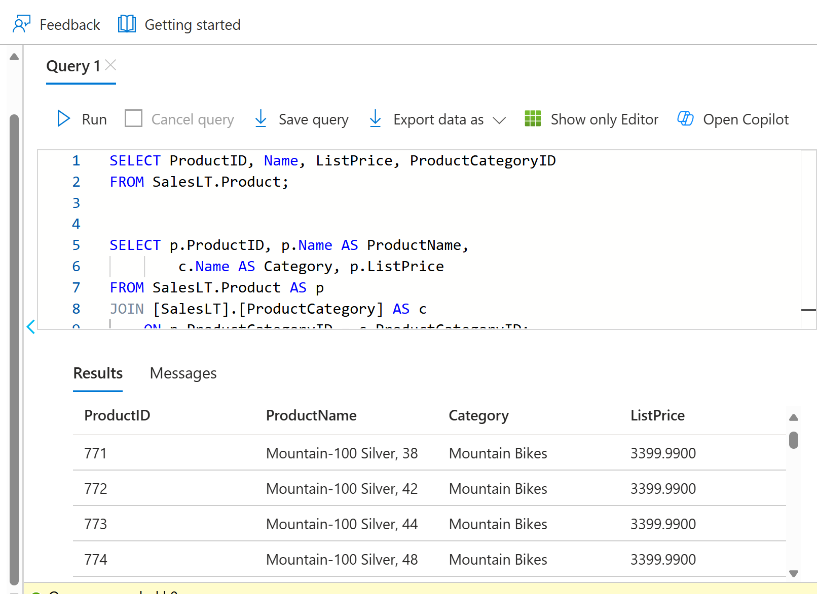

1. Create a Azure storage account with the following settings, keeping the other advanced , networking, data protection, encryption settings default / 2

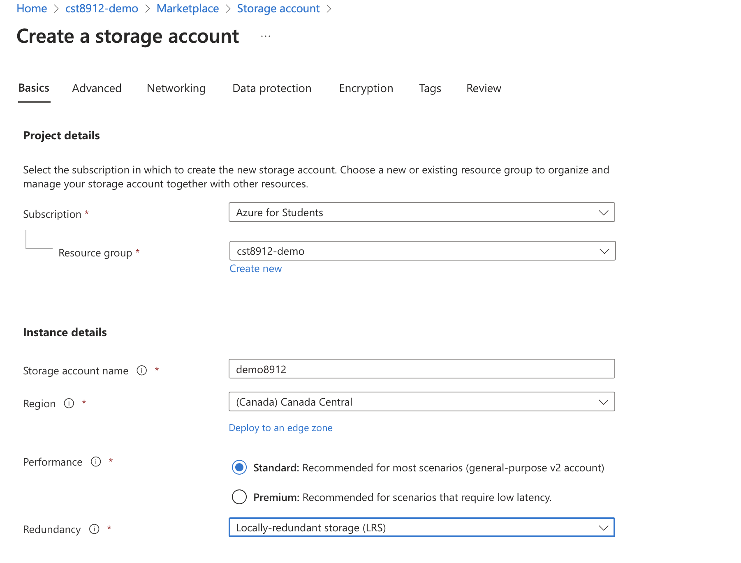

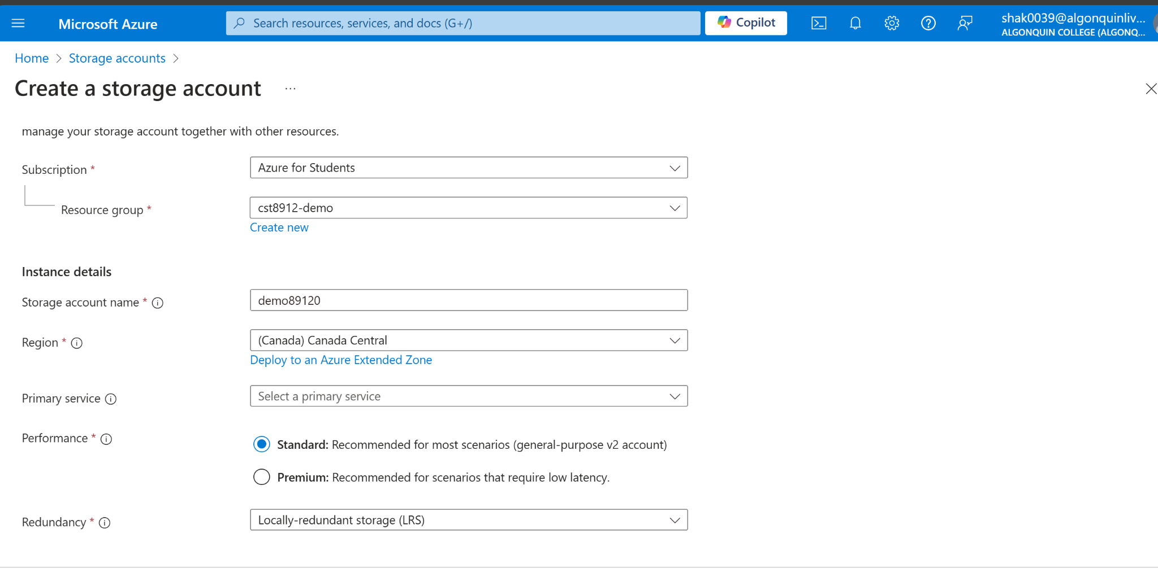

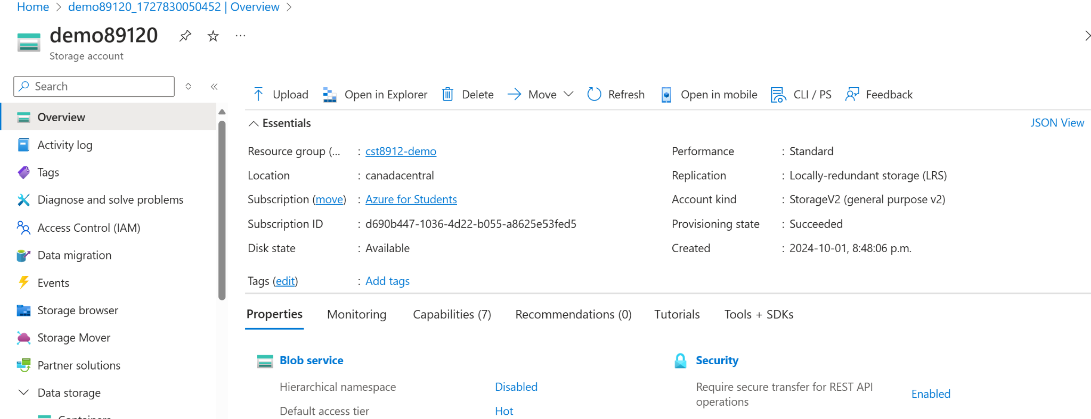

1. Create a container “productdata8912” in storage account / 1

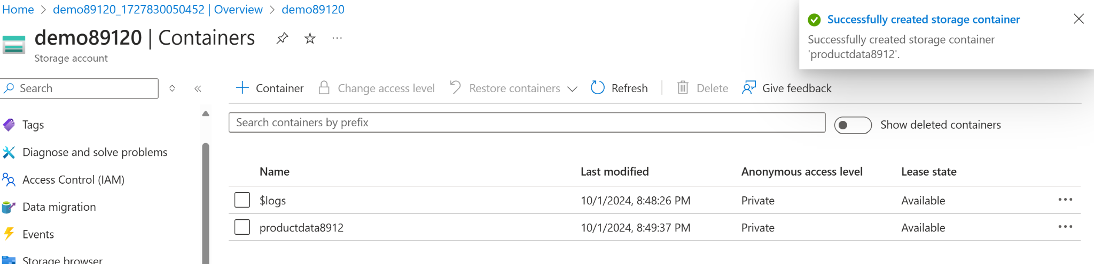

1. Create a new resource in your resource group from the azure portal, search for azure data factory with the following configuration, keeping git configuration, networking, advanced as default. / 10

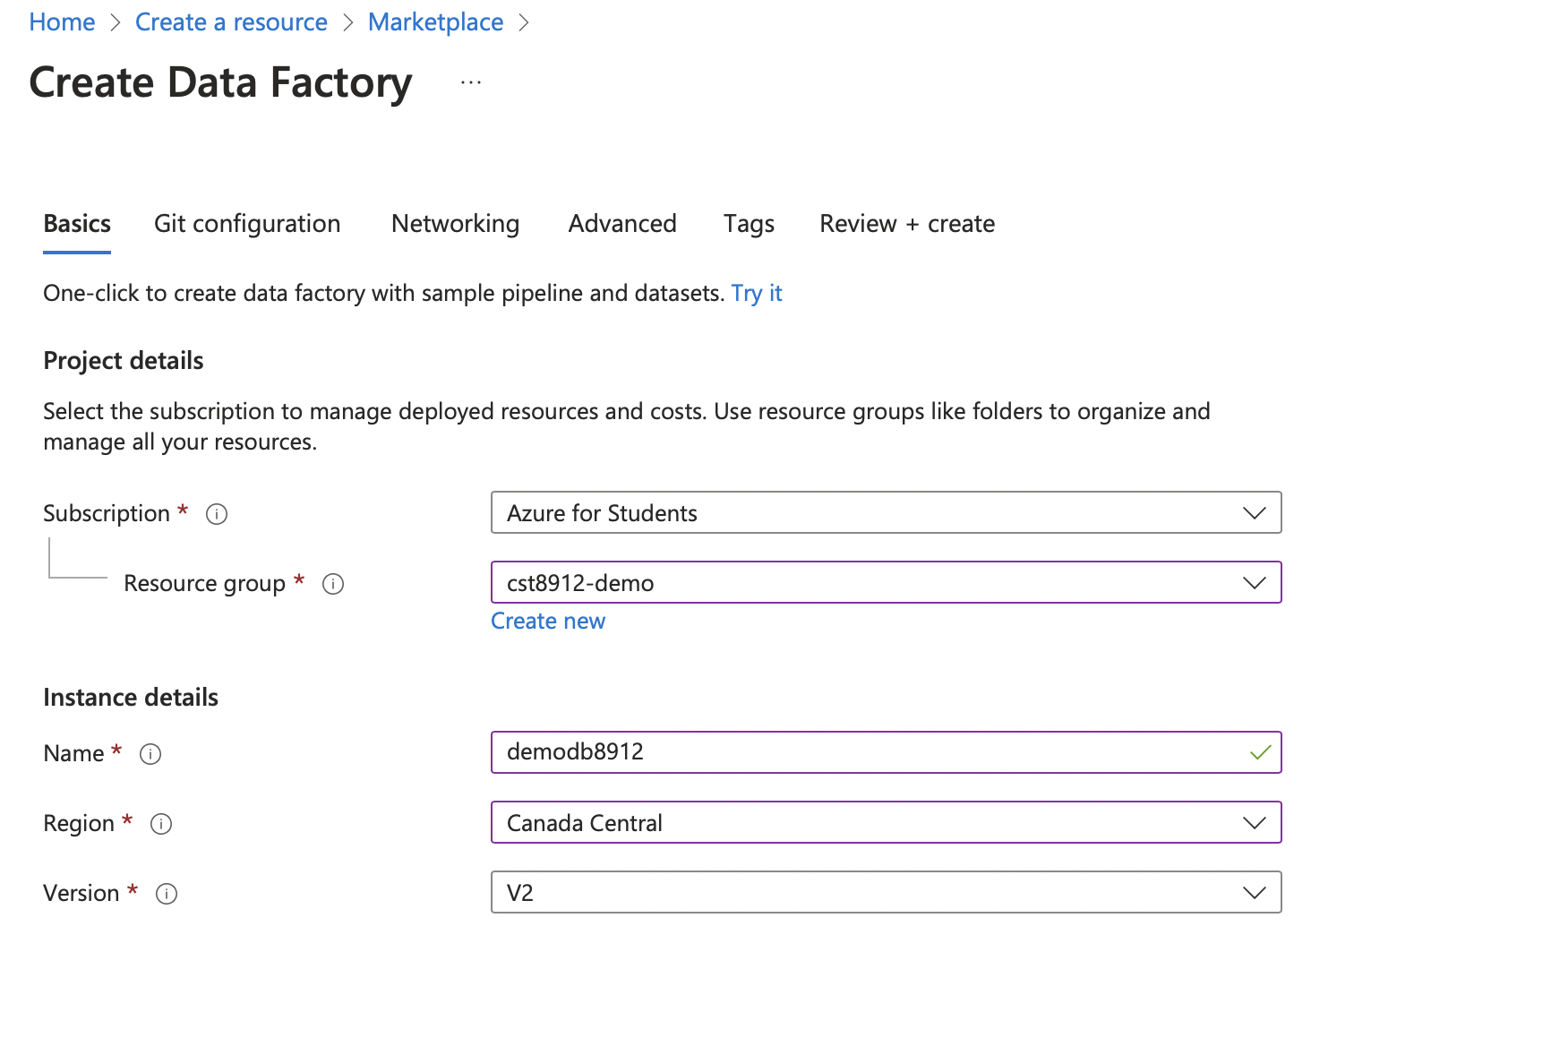

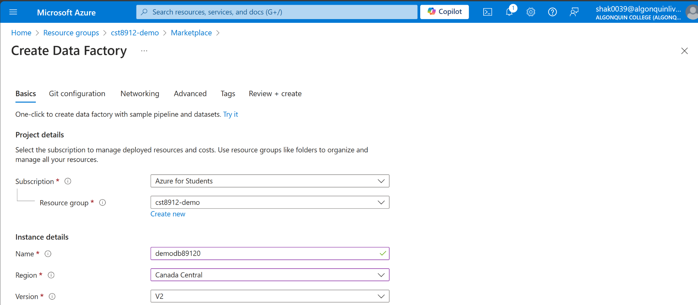

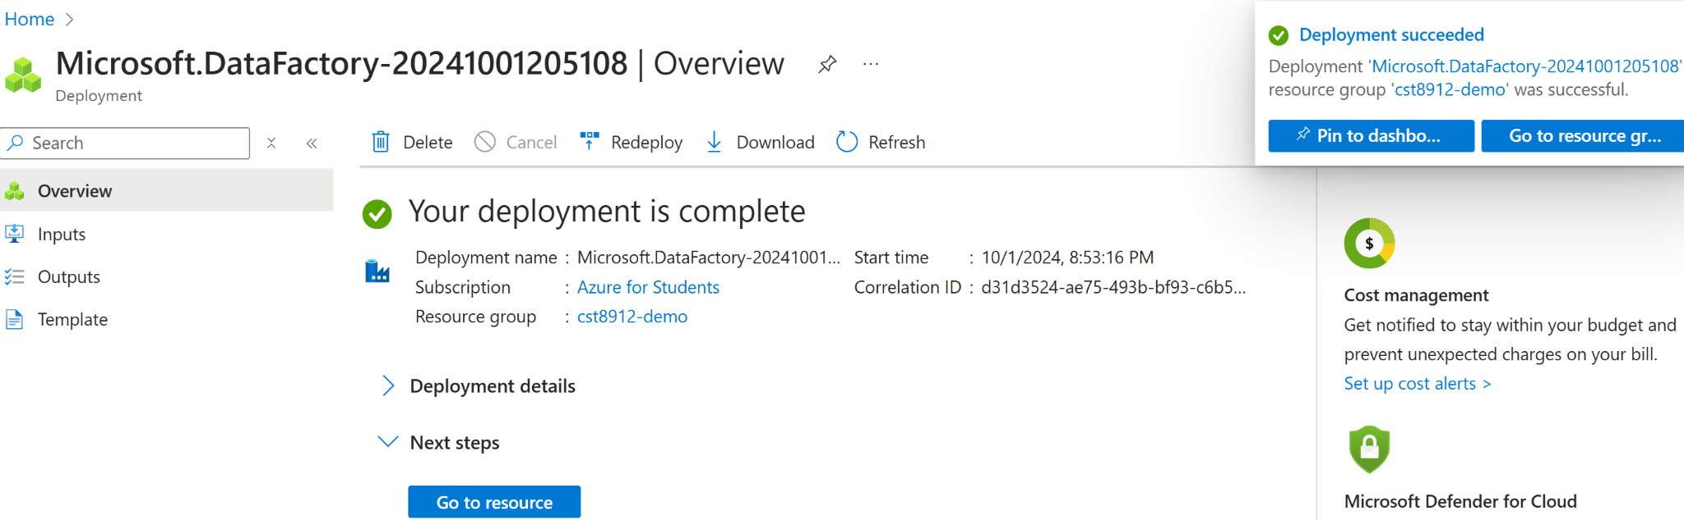

1. Once created launch azure data factory studio

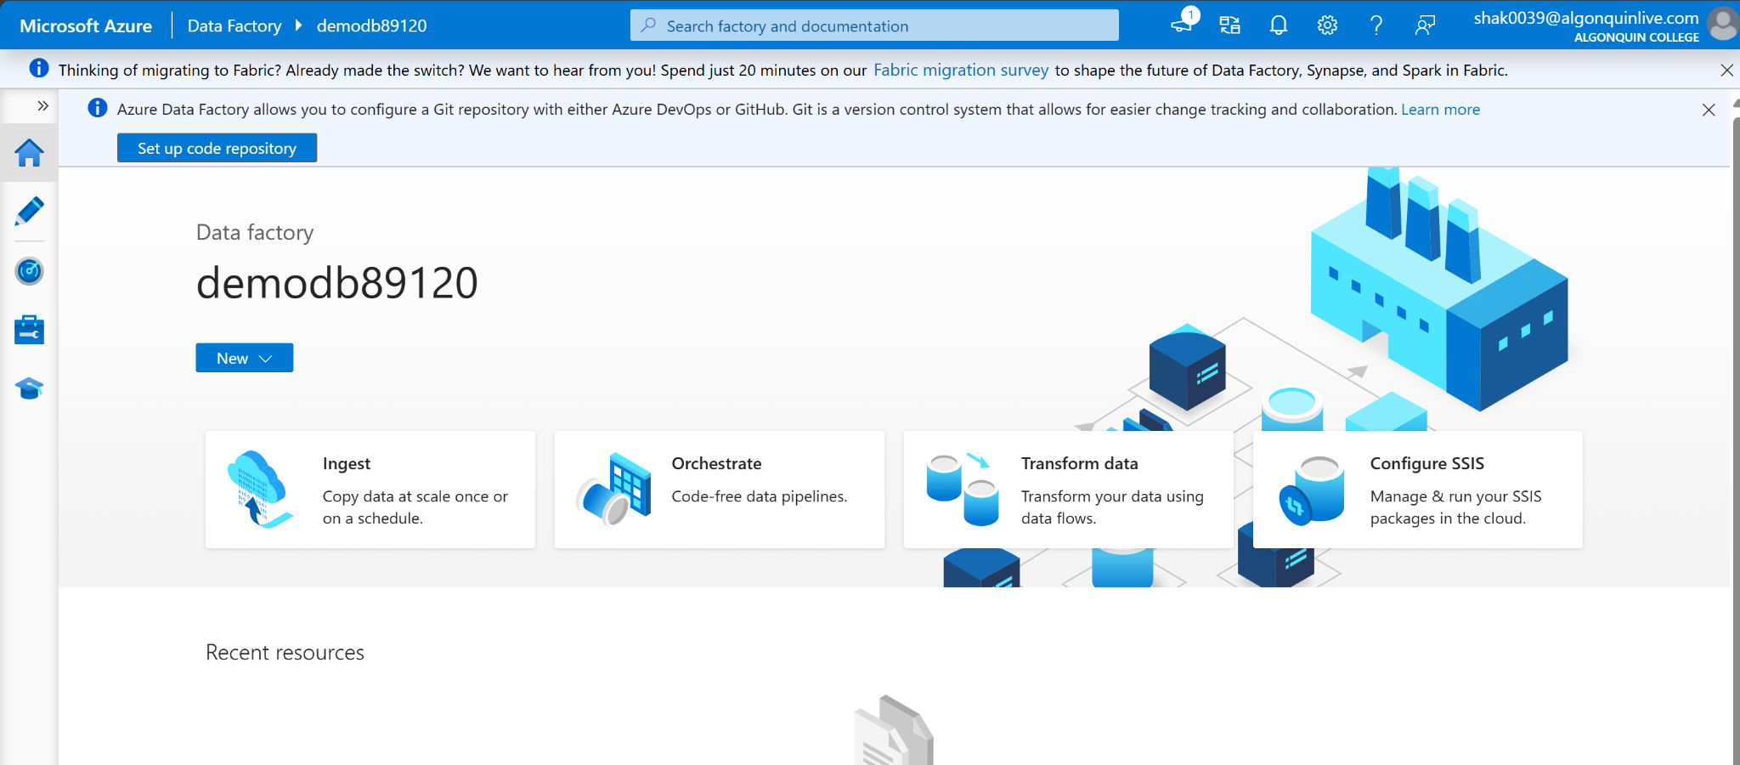

1. On home page, choose option to ingest data
2. Choose task type, built in copy task, and task cadence “run once now”

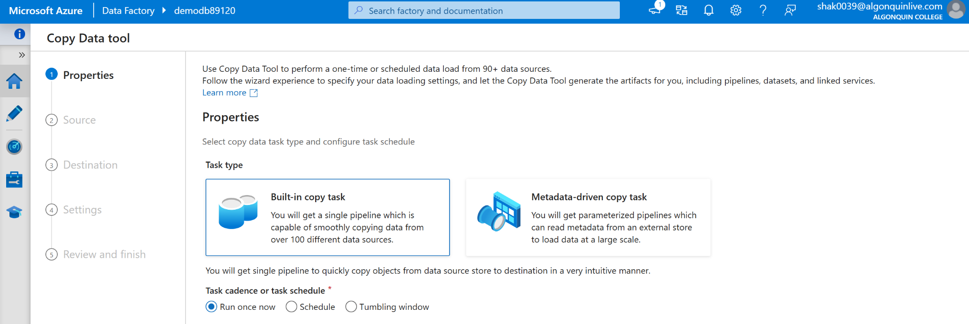

1. In source type choose azure sql database from the dropdown, and connection, choose new connection with the following configuration and test connection  
   Note: This step is creating connection to azure sql database from data factory

**Note**: Make sure you choose the correct database name and password that you created while creating azure sql database, this screenshot is just for reference.  
  
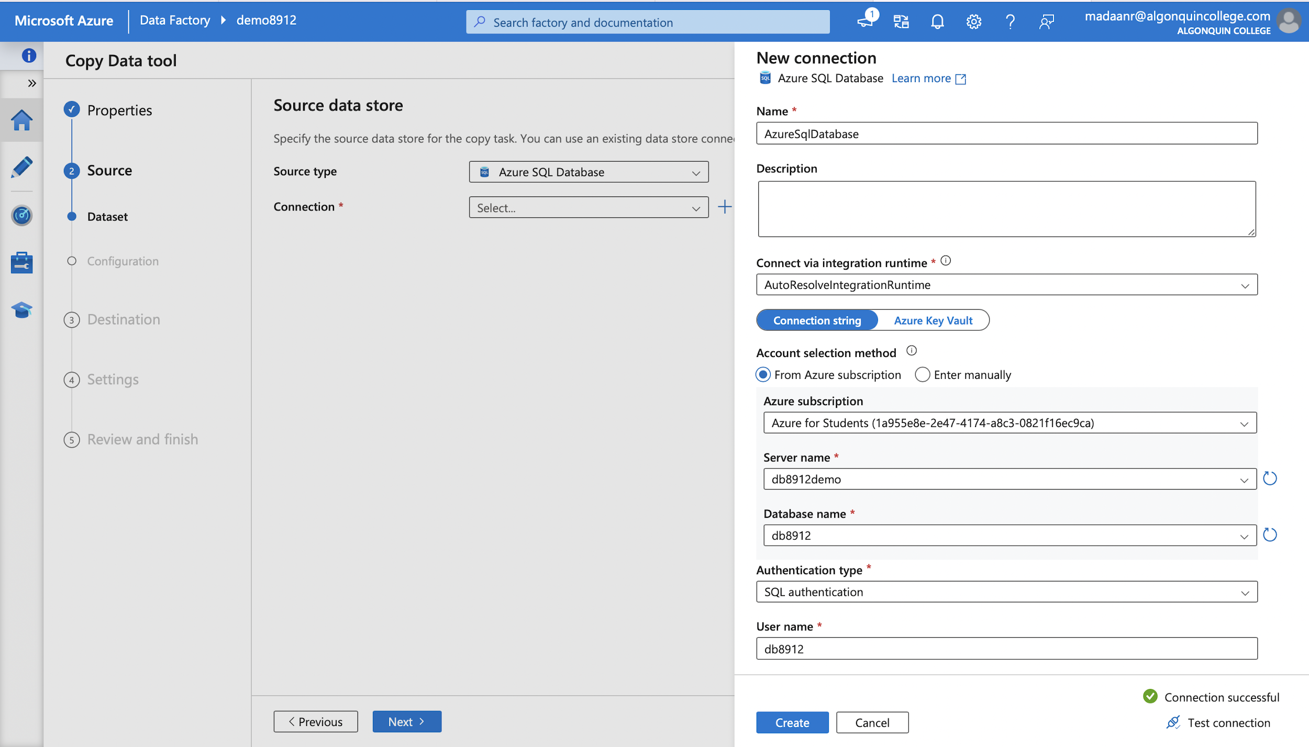

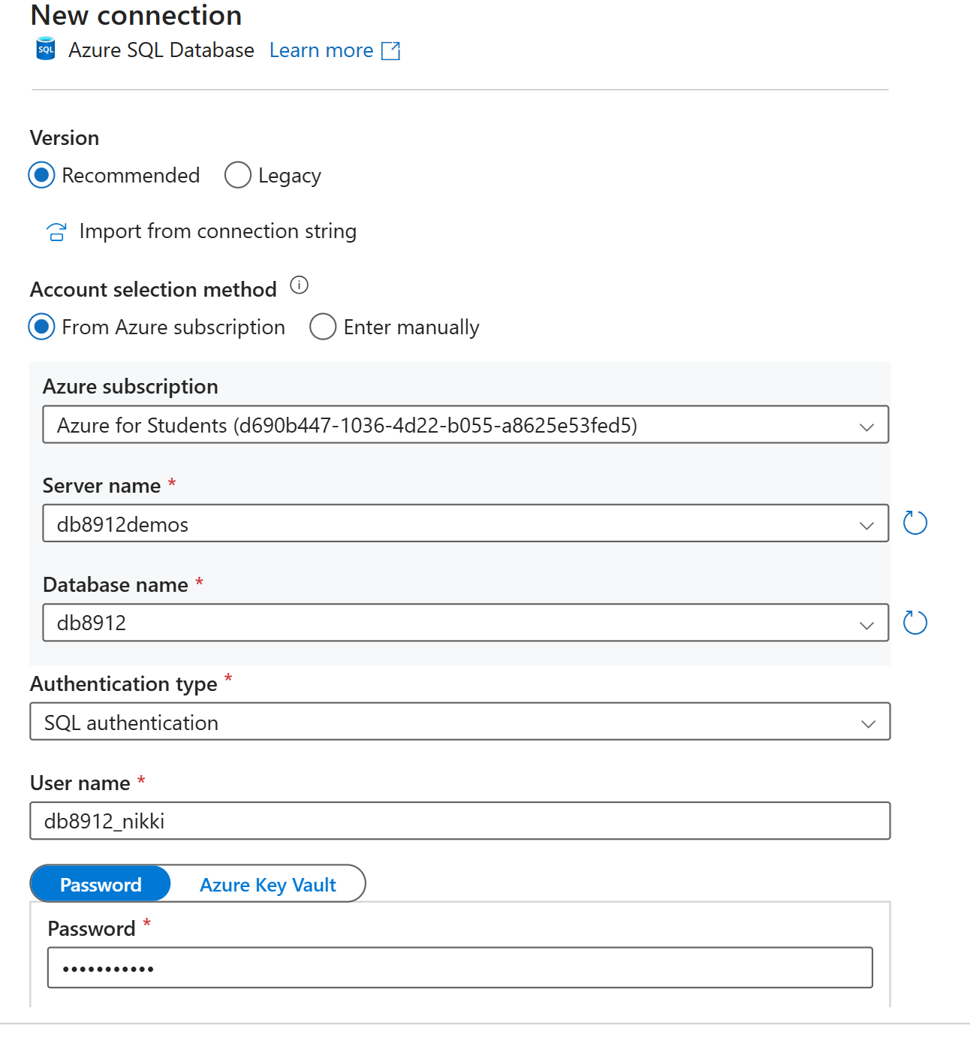

1. Select source table as “ SalesLT.Product” from the dropdown, click next and you can preview data

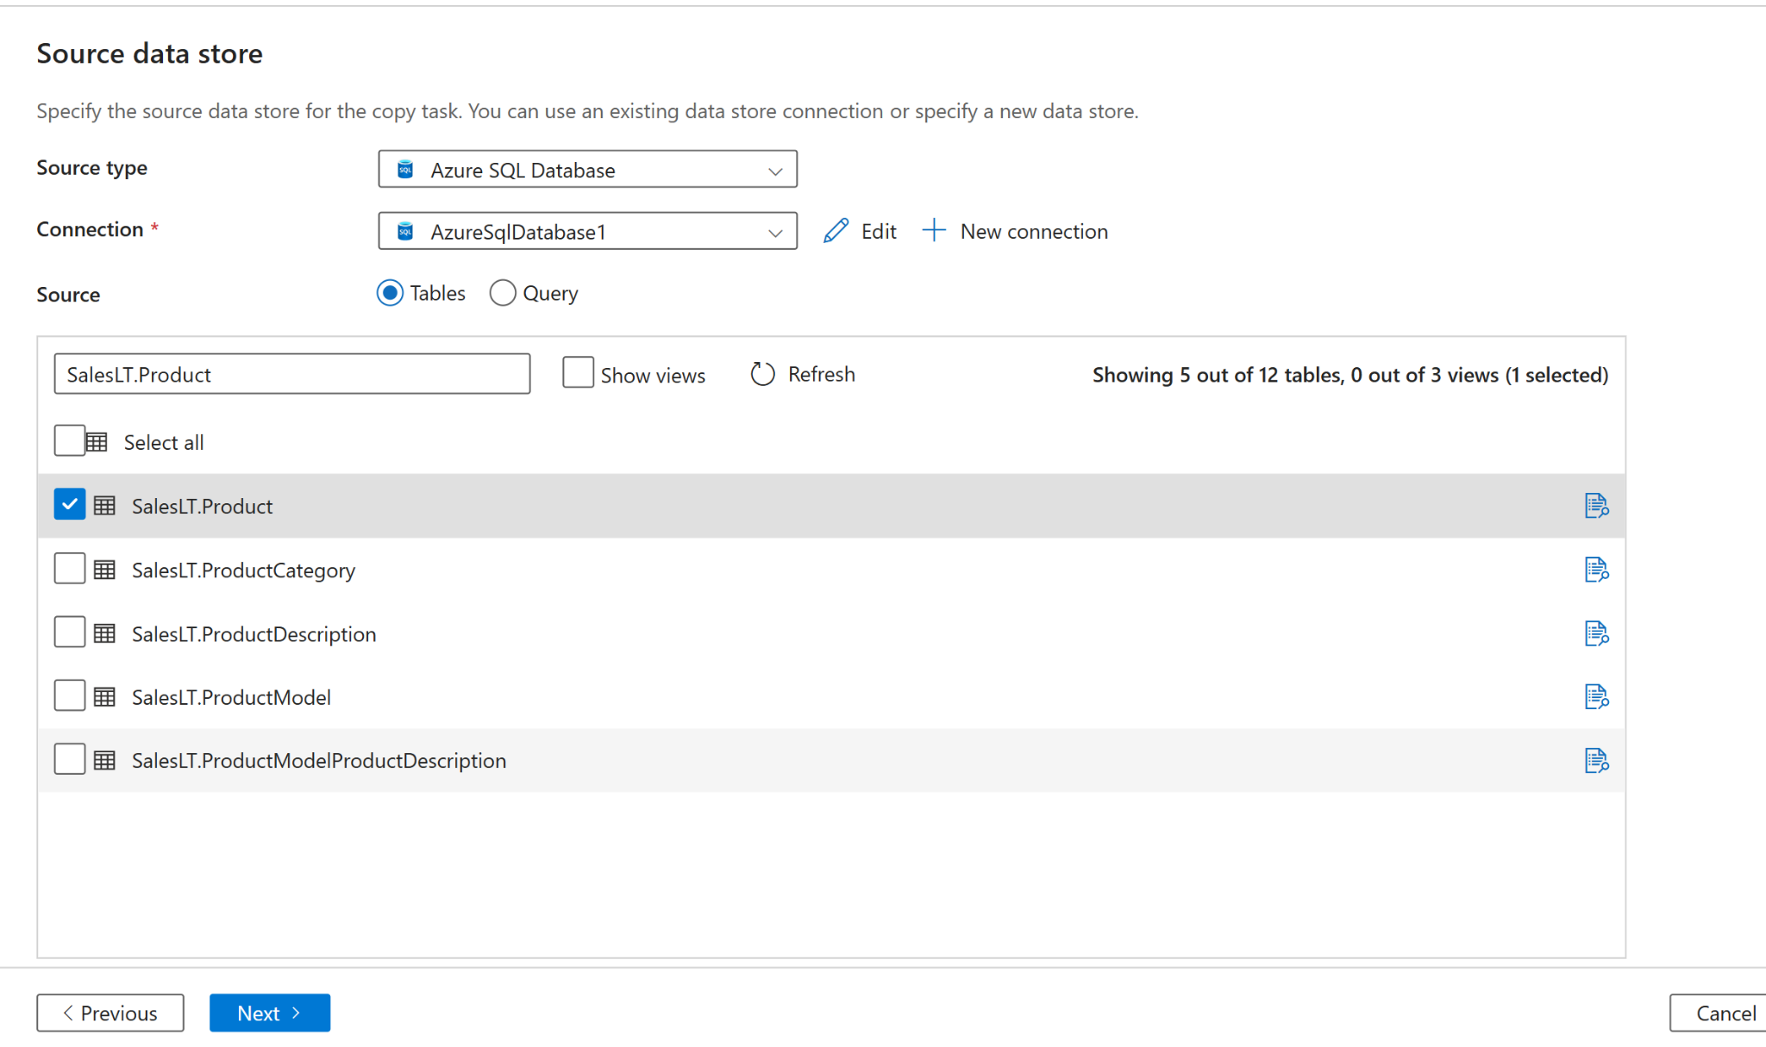

1. Click next, choose destination type, select “Azure Blob Storage” from dropdown

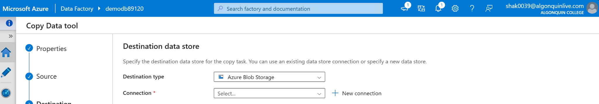

1. Create new connection and test connection to storage account, choose the folder path and enter file name

Note: check the storage account name the you created in this lab.

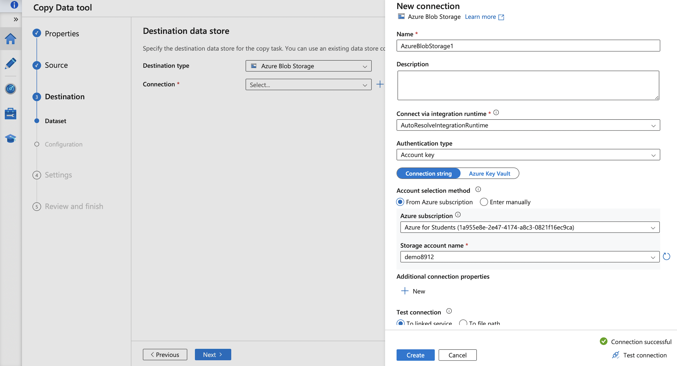

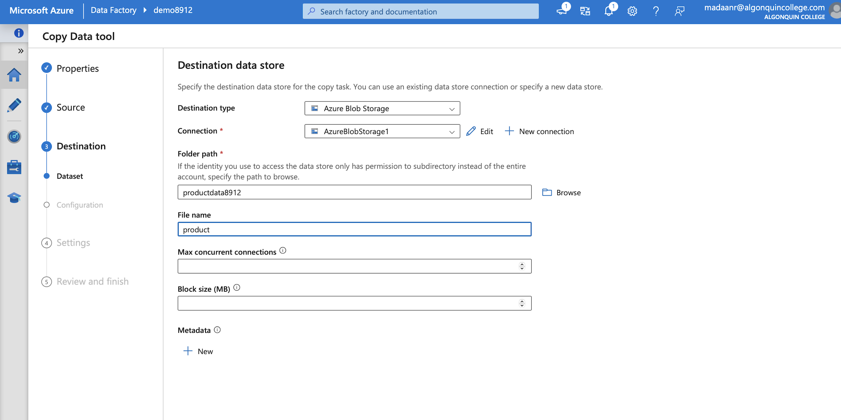

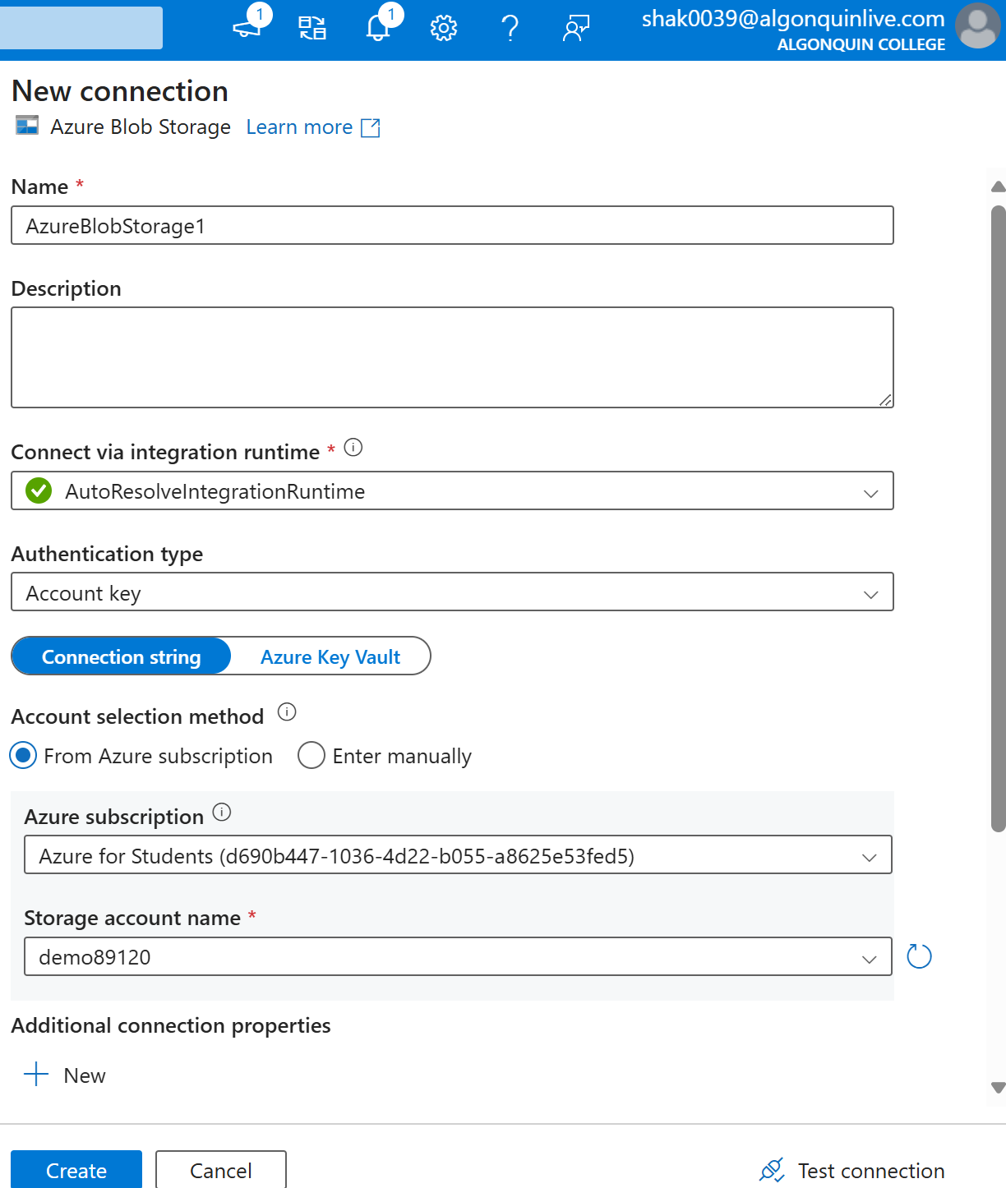

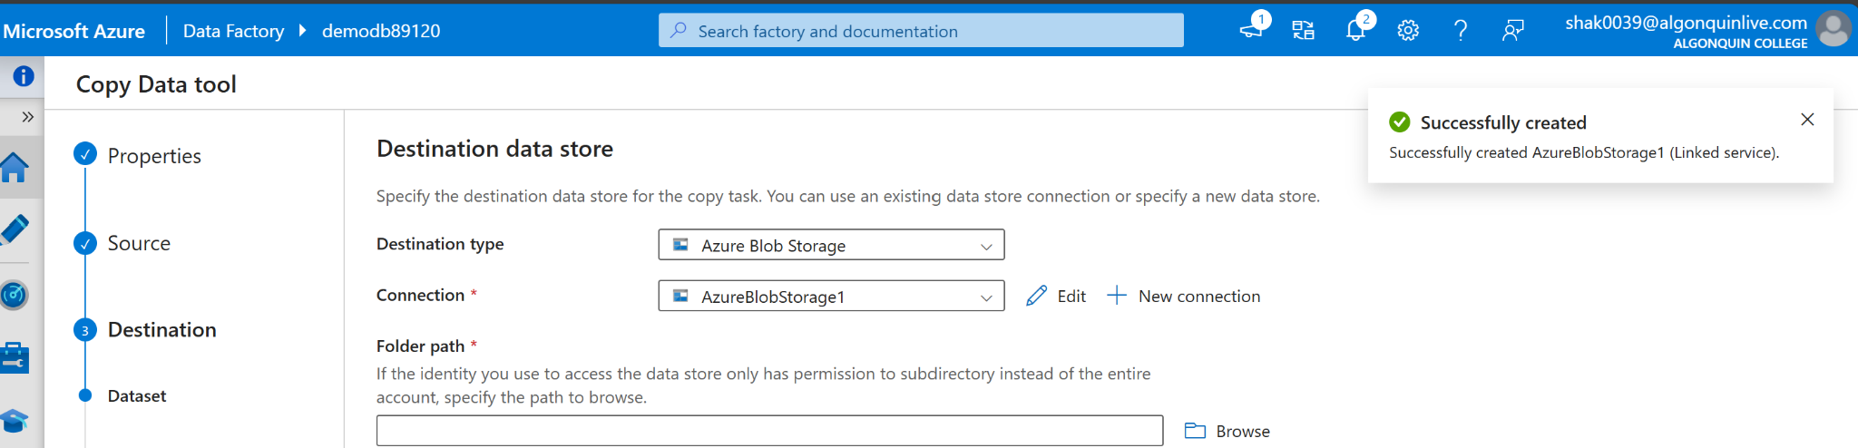

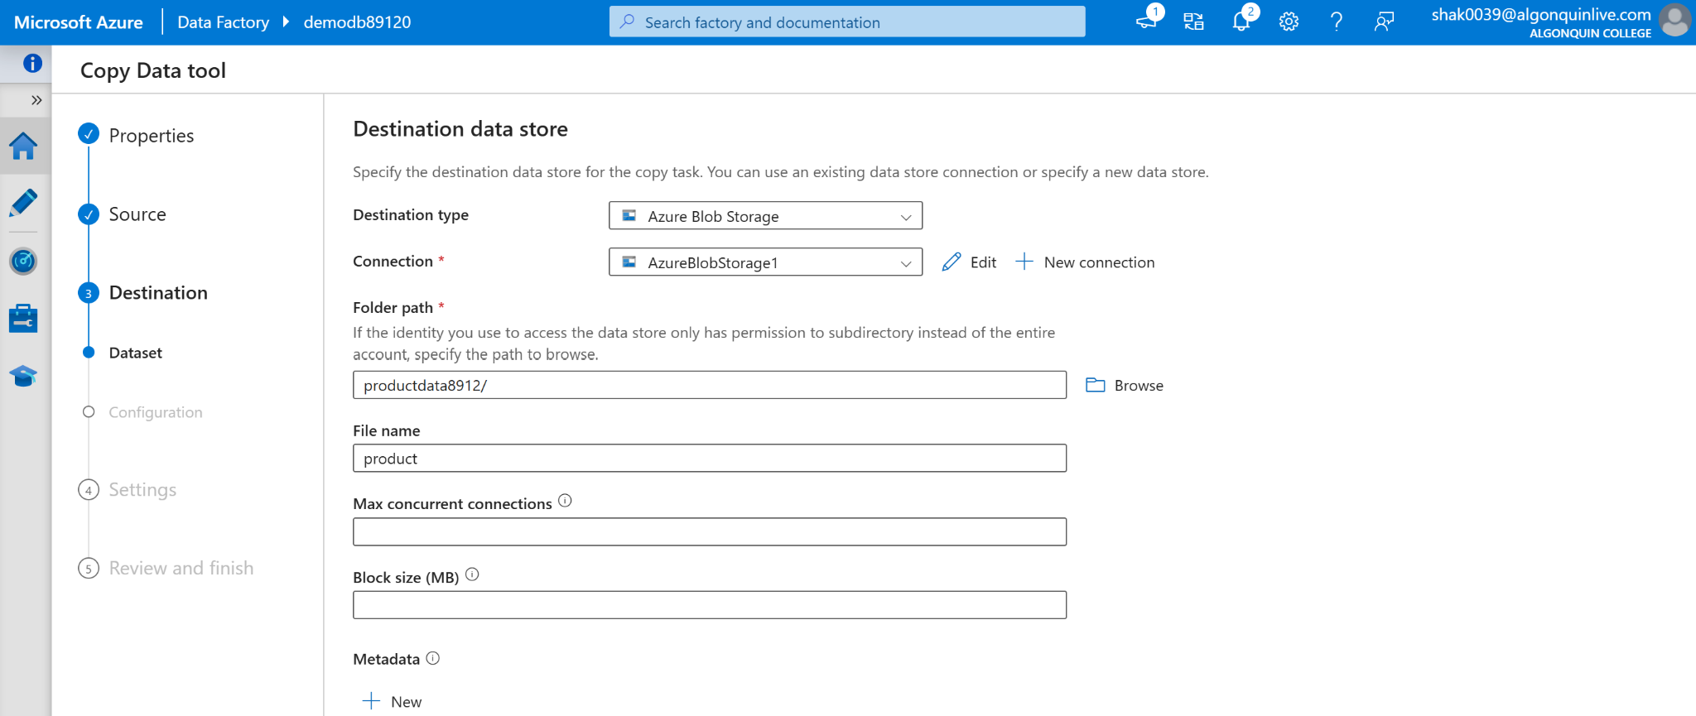

1. Choose the configuration

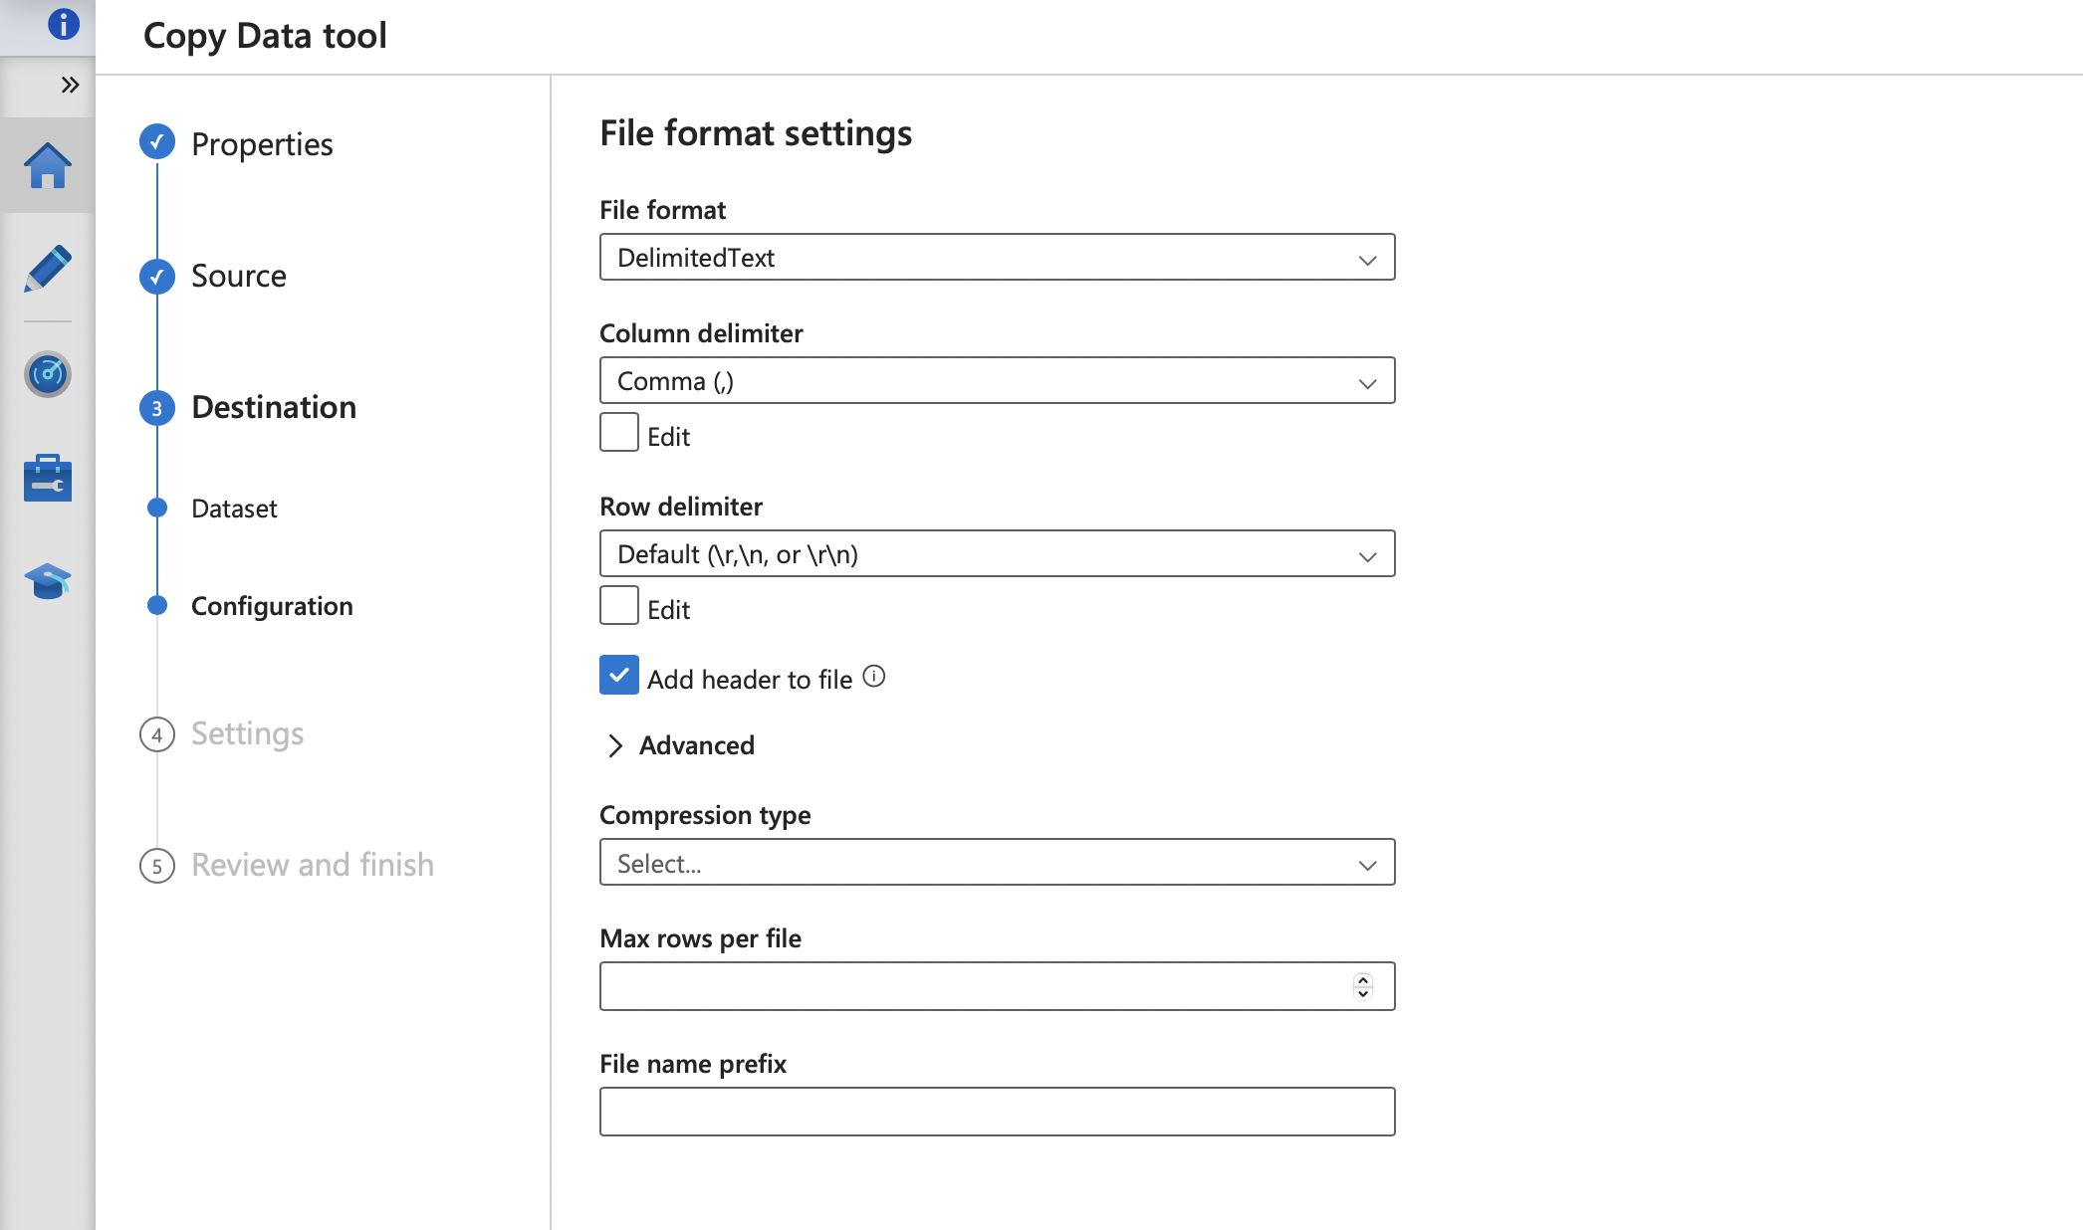

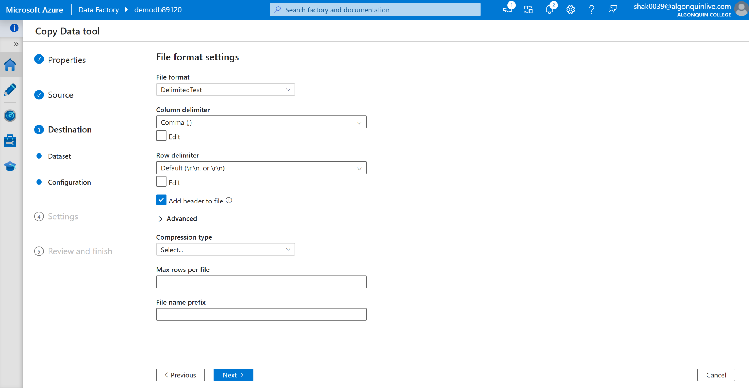

1. Review and finish this pipeline and check the storage account container to see the product csv file copied from the database to storage account

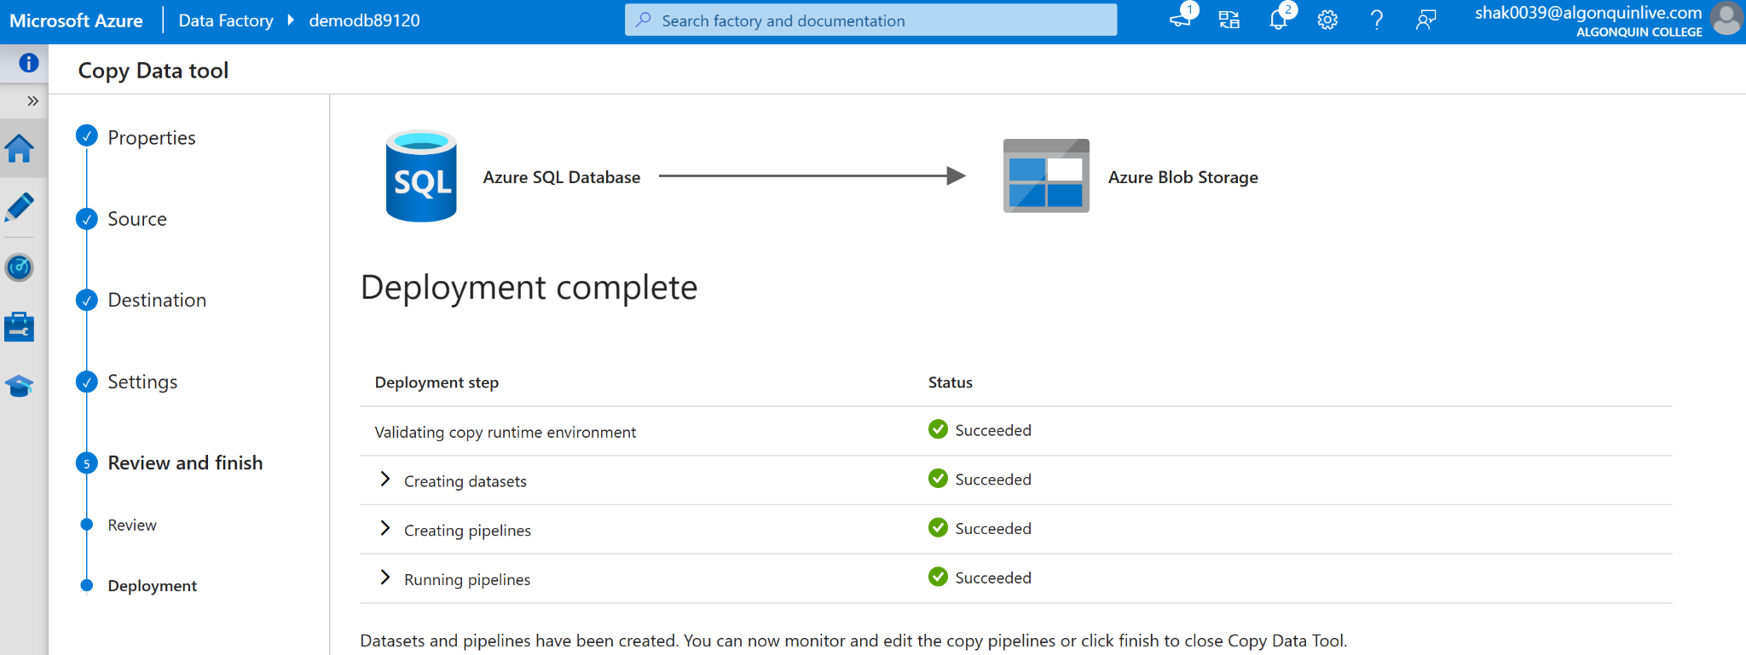

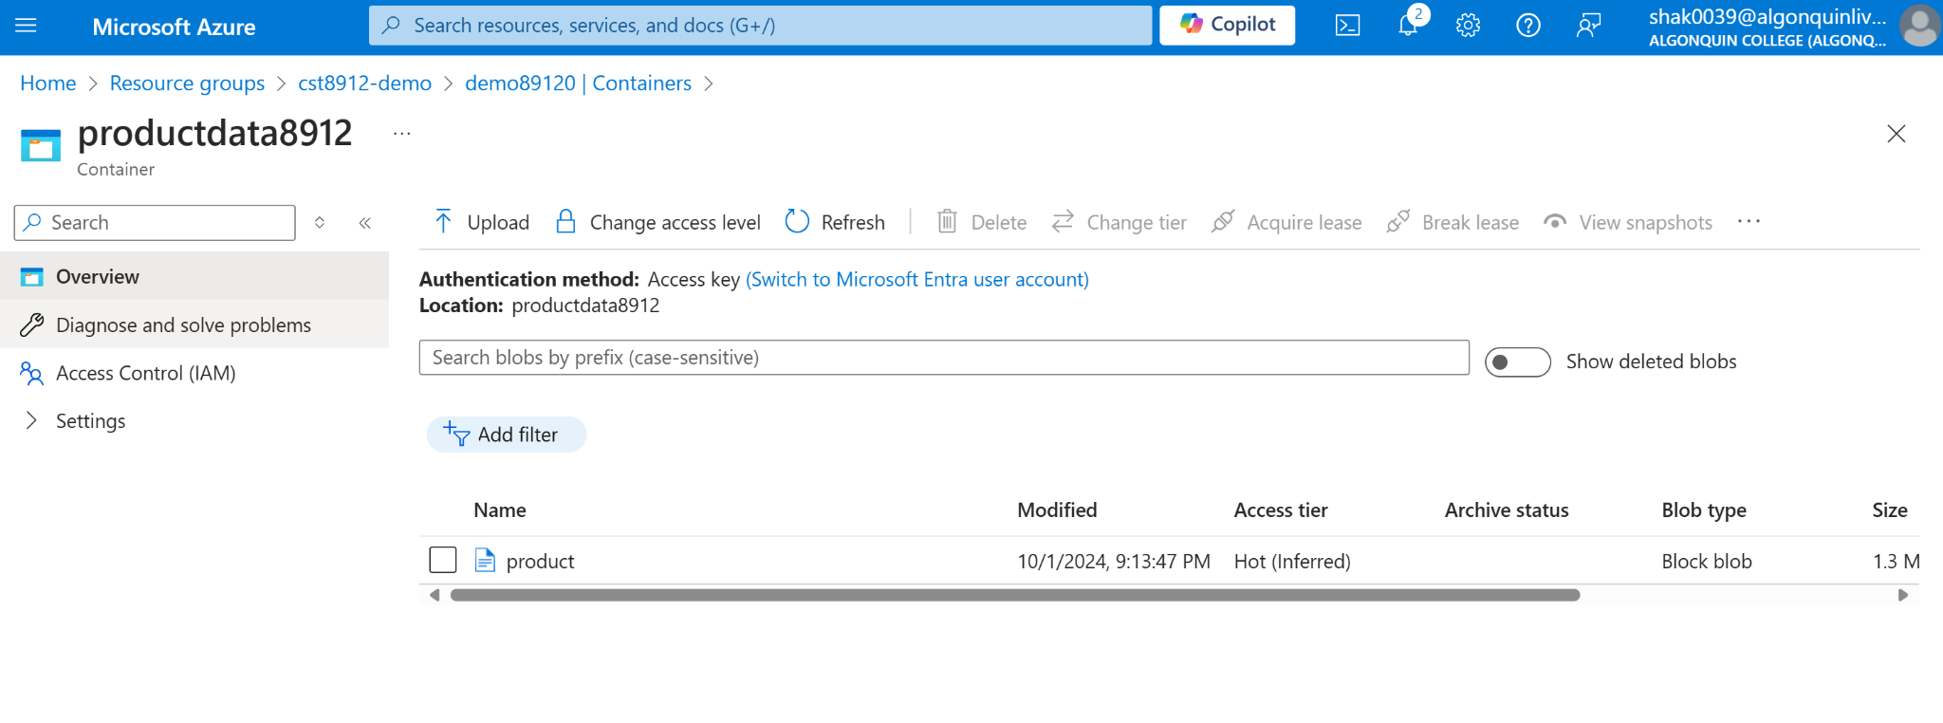

1. After demo delete all the resources created during this lab and create a lab report documenting all the steps performed in the lab along with the screenshots

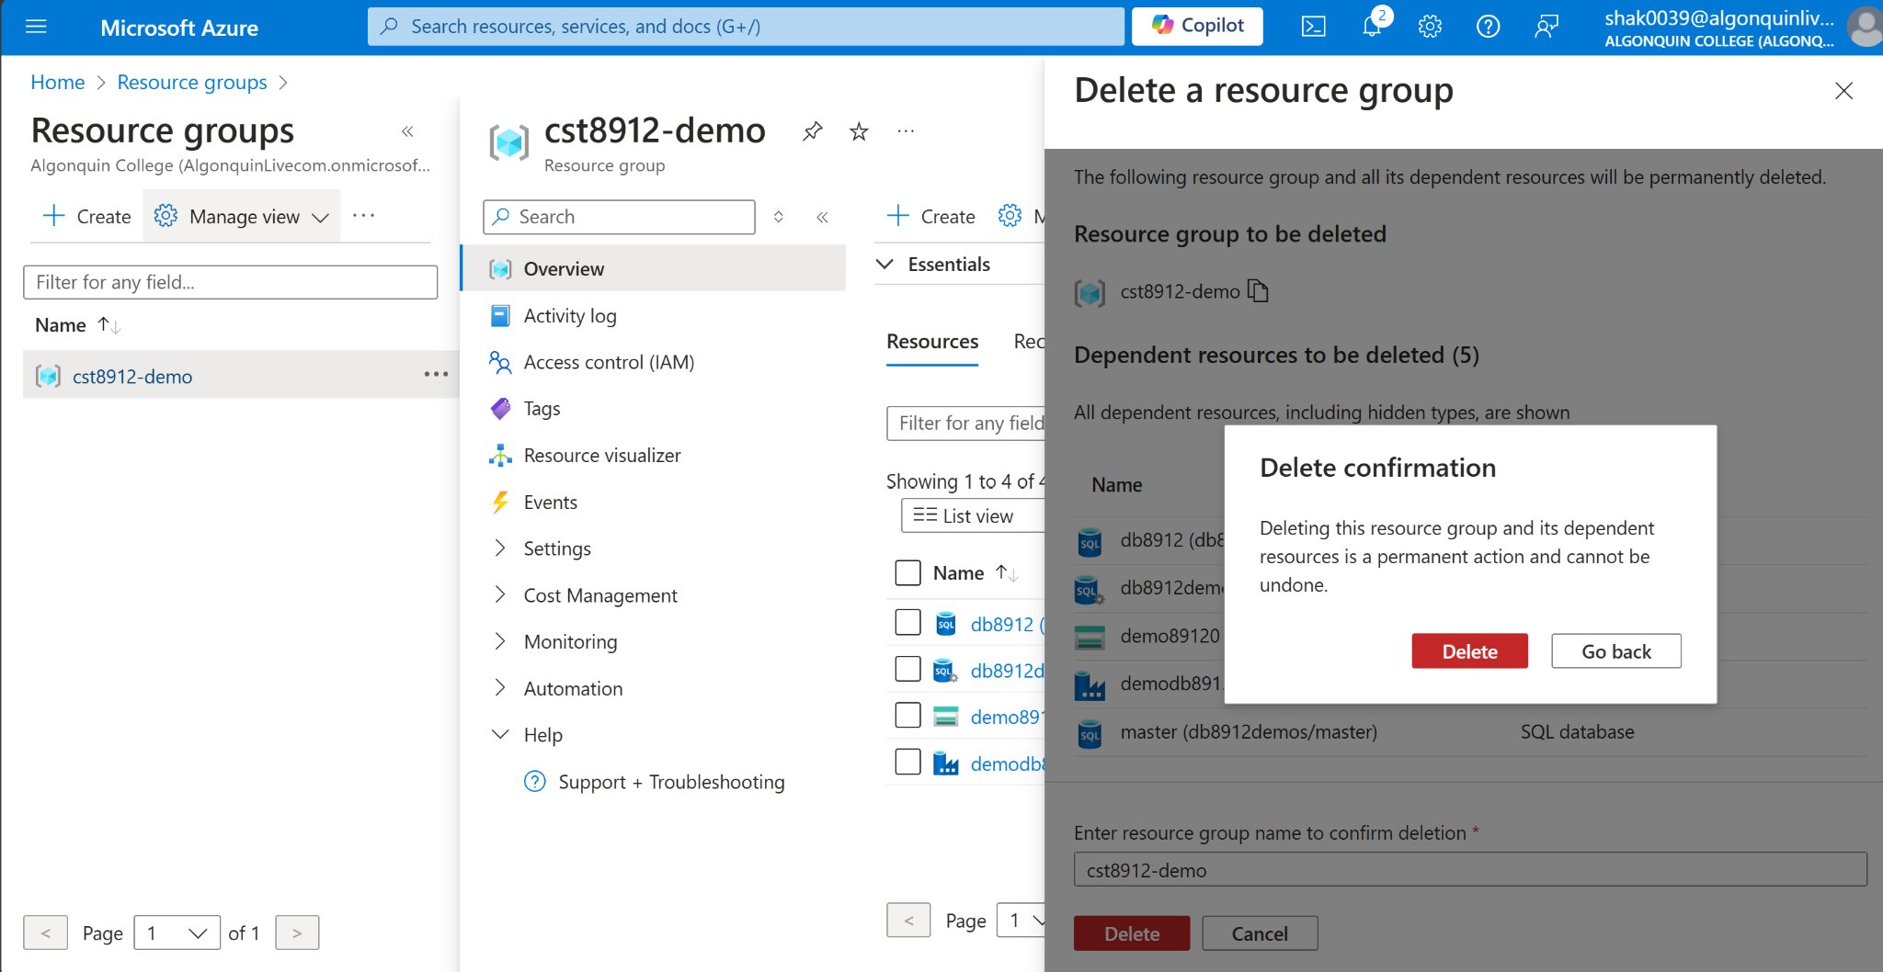

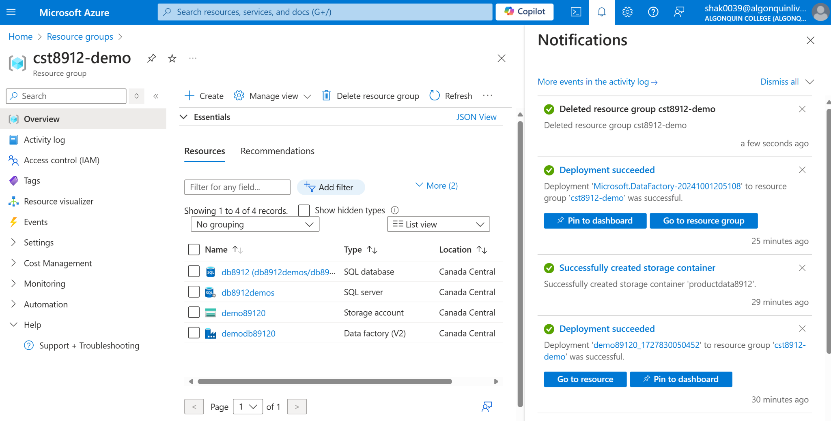

(Lab report on the next page)

Lab Report

In this lab activity, I gained a better understanding of how to deploy and manage cloud SQL databases within the Azure platform. This is very crucial to know, because it allows developers to focus on developing the application without having to think too deeply about the underlying infrastructure. After configuring the database, I created an Azure Storage account to serve as the target for our data transfer. The storage account can handle large amounts of data, and it allows organizations to scale their storage needs easily. Then, I utilized Azure Data Factory to design and execute a pipeline that orchestrates data integration. Luckily, it supports a wide range of data connectors, and this allows companies to combine data from different systems into a single view. Throughout the lab, I gained hands-on experience with cloud architecture layers, understood the interactions between core components, and recognized the benefits of cloud service models in delivering solutions.